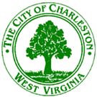

Planning Committee
December 19, 2016
Immediately following the City Council Meeting at 7:00 p.m.
City Hall – 601 Virginia Street – Council Chambers

Agenda

Right of Way Closing
Bill No. 7723 closing, abandoning and discontinuing a portion of an unimproved 10 foot public right of way, located between 131 and 135 East Point Drive, situate in Charleston North District, Kanawha County, West Virginia.

Miscellaneous
Minutes of the November 28, 2016 meeting
Discussion: Proposed Text Amendments

