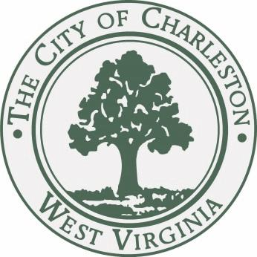

JOURNAL of the PROCEEDINGS
of the
CITY COUNCIL

CITY OF CHARLESTON, WEST VIRGINIA

Regular Meeting – Tuesday, January 20, 2014

at 7:00 P.M.

Council Chamber – City Hall – Charleston, West Virginia

OFFICIAL RECORD

James M. Reishman
City Clerk
Danny Jones
Mayor

CALL TO ORDER

The Council met in the Chambers of the City Building at 7:00 P.M., for the second meeting in the month of January on the 20th day, in the year 2015, and was called to order by the Honorable Mayor, Danny Jones. The invocation was delivered by Councilman Richardson and the Pledge of Allegiance was led by Libby Ballard. The Clerk, James M. Reishman, called the roll of members and it was found that there were present at the time:

BURKA BURTON CLOWSER
DAVIS DENEAULT DODRILL
EALY HAAS HARRISON
HOOVER KIRK KNAUFF LANE MILLER MINARDI NICHOLS PERSINGER REISHMAN RICHARDSON RUSSELL SALISBURY SHEETS SMITH SNODGRASS TALKINGTON WARE WHITE
MAYOR JONES

With twenty-five members being present, the Mayor declared a quorum present.

Pending the reading of the Journal of the previous meeting, the reading thereof was dispensed with and the same duly approved.

CLAIMS

- A claim of Cynthia Rucker, 618 Hunt Ave., Charleston, WV; alleges damage to personal property.
Refer to City Solicitor.
- A claim of Catherine Layne, 214 Elm Street, Charleston, WV; alleges damage to personal property.
Refer to City Solicitor.

PUBLIC HEARING

The Mayor called the public hearing on Bill No. 7643 open and asked for any public speakers to come forward and address council.
Russ Young spoke in favor of the bill and stated that having additional council members on the CURA board will ensure that the City is in touch with what business is conducted within the board.
With no one else from the public to speak regarding the bill, The Mayor declared the public hearing on Bill No. 7643, closed.

MISCELLANEOUS RESOLUTIONS

EXECUTIVE DEPARTMENT
CITY OF CHARLESTON
PROCLAMATION
By the Mayor

WHEREAS: Recognizing the unfortunate reality that far too many of veterans in the United States become homeless after they have served our nation, First Lady Michelle Obama issued a challenge last year for mayors in cities across the nation to end veteran homelessness by the end of 2015; and

WHEREAS: The White House has directed the Department of Housing and Urban Development, Department of Veterans Affairs and U.S. Interagency Council on Homelessness to work with governments and organizations fighting homelessness in our communities toward meeting this challenge; and

WHEREAS: Leaders in Charleston recognize that veteran homelessness is not an unsolvable issue because by focusing resources and renewing our community’s commitment to help veterans in need, we can end veteran homelessness in our city and our country; and

WHEREAS: In accepting the challenge last year, I directed the Mayor’s Office of Economic and Community Development (MOECD) to make this issue a priority for 2015 and work closely with Roark Sullivan Lifeway Center, other members of the Kanawha Valley Collective, the Charleston Kanawha Housing Authority, the local Veterans Affairs Medical Center and regional offices of the federal agencies involved on a plan to move veterans from living on the streets or in tents into shelters with supportive services and then into more permanent supportive housing; and

WHEREAS: With “Registry Week” approaching near the end of this month, these partners among public agencies, non-profit organizations and private sector supporters have made significant progress over the past several months in identifying veterans who are or have been homeless, by working hard to provide better options for them and through addressing the needs of new people in need who enter the system every month.

NOW THEREFORE, I Danny Jones, Mayor of the City of Charleston, do hereby proclaim 2015 as:

THE YEAR TO END VETERAN HOMELESSNESS

In the City of Charleston, urge all citizens to stand up for our veterans who have fought for our freedom by helping those in need find a place to live.

In witness hereof, I have hereunto set my hand and caused the Seal of the Executive Department to be affixed this 20th day of January 2015.

_______________________
DANNY JONES, MAYOR

The Mayor called for a voice vote. With unanimous vote in the affirmative, the proclamation was confirmed.

The Clerk read the following resolution:

Resolution No. 545-15 - “Designating a Select Committee of Council to perform certain functions for the Council in the City of Charleston Primary Election to be held on March 7, 2015.”

WHEREAS, the code of West Virginia, 1931 as amended, requires the Council of a municipality to perform certain functions in the conduct of an election; and

WHEREAS, the size of Council makes it impractical to perform these functions as a body, and the West Virginia Secretary of State has directed that such functions be done by committee; NOW THEREFORE,

Be it Resolved by the council of the City of Charleston, West Virginia:

That Robert Reishman, Chairman, Mary Beth Hoover and Jerry Ware, members of the Council
of the City of Charleston, West Virginia, are hereby designated as the Select Committee to perform all required functions in connection with the City of Charleston Primary Election to be held on March 7, 2015, including but not limited to a canvass of votes cast.

Councilman Reishman moved to approve the Resolution. Councilman Lane seconded the motion. With a majority of members elected recorded thereon as voting in the affirmative the Mayor declared Resolution 545-15 adopted.

COMMUNICATIONS

Dear Mayor Jones and Council members:

I am requesting Council’s approval to withdraw the following bills:

Introduced by Council Member Mary Jean Davis on January 5, 2009: Bill No. 7373 - A Bill closing, abandoning and discontinuing as a public right of way a portion of the street known as Hussey Ferraro Way, in the City of Charleston, West Virginia; conveying said portion of the street to the abutting property owner, Roark-Sullivan Lifeway Center, consistent with the terms and conditions herein; and reserving a sewer easement for the City of Charleston.

Introduced by Council person Mary Jean Davis on August 16, 2010: Bill No. 7428 - amending the Zoning Ordinance of the City of Charleston, West Virginia, enacted the 1st day of January 2006, as amended, and the map made a part thereof, by rezoning from an C-10 district to a I-2 district, that certain parcel of land situate at 10 Spring Street, Charleston, West Virginia.

Introduced by Council member Marc Weintraub on December 3, 2012: Bill No. 7550- A bill amending the Zoning Ordinance of the City of Charleston, West Virginia, enacted the 1st day of January 2006, as amended, and the map made a part thereof, by rezoning from an R-6 district to a R-4 district, that certain parcel of land situate on 94.79 m/l areas of land located between McDavid Lane and Bakers Fork Road and adjacent to Cannady Drive, Charleston, West Virginia.

Introduced by Council member Rick Burka on January 7, 2013: Bill No. 7557- Bill No amending the Zoning Ordinance of the City of Charleston, West Virginia, enacted the 1st day of January 2006, as amended, and the map made a part thereof, by rezoning from an R-2 district to an R-10 district, that certain parcel of land situated at 700 Chappell Rd, Charleston, West Virginia.

Sincerely,

Mary Jean Davis
Planning Committee Chair

The Mayor called for a voice vote. With unanimous vote in the affirmative, the bills were withdrawn.

REPORTS OF COMMITTEES

COMMITTEE ON ENVIRONMENT AND RECYCLING

Councilperson Edward Talkington, Chairperson of the Council Committee on Environment and Recycling, submitted the following report:
- Your committee on Environment and Recycling has had under consideration Bill No. 7644, and reports the same to Council with the recommendation that the bill do pass.
Bill No. 7644: “A BILL to establish a Restricted Use Area West Side of Charleston for the purpose of prohibiting the drilling into and the extraction of groundwater within the Restricted Use Area except for ground water monitoring and/or remediation.

WHEREAS, an approximately 1.45 acres/63,000 square feet parcel of land located at 515 Pennsylvania Avenue (the “Site”) has been the subject of environmental assessment and risk-based remediation by Speedway LLC, as part of their Voluntary Remediation agreement # 08987 with the State of West Virginia Department of Environmental Protection (“DEP”) that will allow the sale and development of a brownfield site which contained “chemicals of concern” resulting from the former operation of gas station on the Site; and

WHEREAS, the environmental assessment has indicated that “chemicals of concern” from previous businesses located on the Site are now migrating with the flow of ground water from the Site into surrounding ground water; and

WHEREAS, Speedway LLC, in cooperation with the DEP, has notified the City of the migration, and has requested that the City take protective action to prevent the uncontrolled exposure to the chemicals of concern in the ground water; and

WHEREAS, the City of Charleston has the duty and authority under W. Va. State Code § 8-12-5(23) to provide for the elimination of hazards to public health and safety; and

WHEREAS, the Kanawha Charleston Health Department is the governmental agency with authority to issue permits with respect to ground water drilling within Kanawha County, including within the City of Charleston;

Now, therefore, be it Ordained by the Council of the City of Charleston, West Virginia:

THAT there is hereby established within the City of Charleston a Restricted Use Area in which the drilling into and extraction of ground water is prohibited. The Restricted Use Area is defined as Parcels 72 through 78 as set forth on Map Number 27, West Charleston on file in the Kanawha County Assessor’s Office (the “Parcels”), including alleyways adjacent to the Parcels, and sections of roadway abutting the Parcels from the northern border of Lee Street to the Parcels and the eastern border of Pennsylvania Avenue to the parcels, all as depicted in the map attached as Exhibit 1. This area represents the maximum predicted extent of contamination migration (100 feet) plus a conservative safety factor of 100 feet.

Ground water is defined as water occurring in the zone of saturation beneath the seasonal high water table, or any perched water zone.

This prohibition applies to any excavation or penetration in the ground, whether drilled, bored, cored, driven or jetted that enters or passes through ground water for purposes of extracting ground water, including but not limited to, a water supply, exploration for water, dewatering, or heat pump wells.

Nothing contained in this ordinance shall prohibit the extraction of ground water from installation, modification, operation, repair or removal of monitoring and/or remediation wells when operated with the authorization of or at the direction of state or federal environmental officials or agencies.

Nothing contained in this ordinance shall prevent any construction activity within the Restricted Use Area which is not for the purpose of extracting ground water and does not contemplate the disruption of ground water during construction. Additionally, nothing in this ordinance shall prohibit any construction activity within the Restricted Use Area which is not for the purpose of extracting ground water but that may result in incidental disturbance of ground water, provided all state laws and regulations applicable to construction under such conditions, including, but not limited to, all laws and regulations enforced and promulgated by the DEP, are verifiably met. If incidental disturbance of ground water occurs, the contractor shall provide notice of the disturbance to the Office of Environmental Remediation of the Department of Environmental Protection (304-926-0455), and reference Voluntary Remediation file # 08987.

Nothing contained in this ordinance shall prevent the use of ground water in the Restricted Use Area if the ground water has been treated to meet state standards appropriate for its intended use prior to any use. Nothing contained in this ordinance shall prevent ground water monitoring and/or remediation of groundwater.

Upon passage, the Clerk shall submit a certified copy of this ordinance to the Kanawha Charleston Health Department for their use when evaluating applications for ground water drilling within the City of Charleston.

Upon passage, a copy of this Ordinance shall also be provided to the City of Charleston Building Department, the City of Charleston Planning and Zoning Department, and the City of Charleston Engineering Department, and shall be kept on file in the City Clerk’s Office.

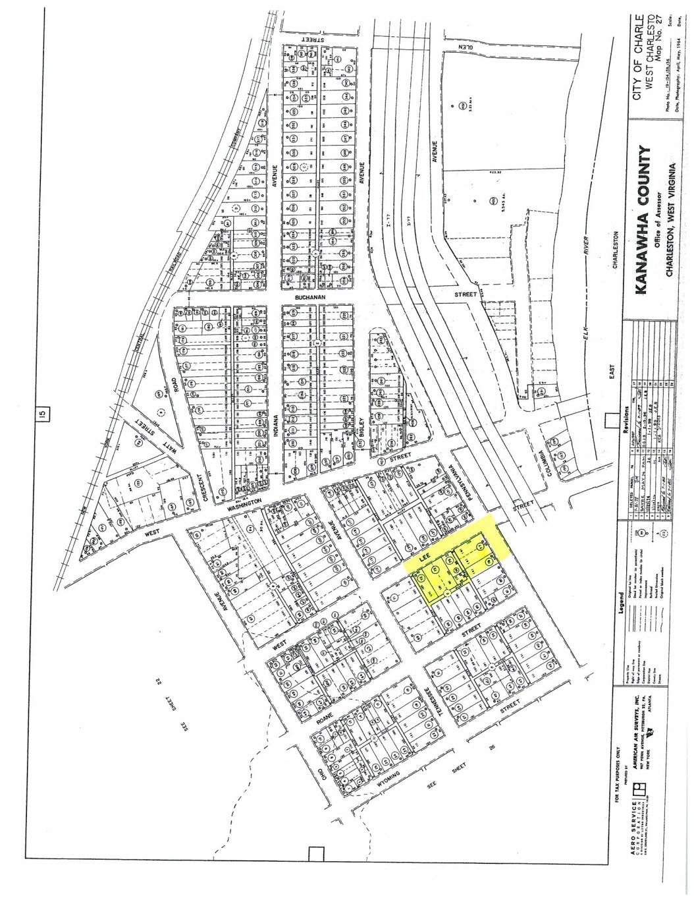

Councilman Reishman moved to pass Bill No. 7644. Councilman Lane seconded the motion. The Mayor opened the floor for discussion of the bill.
There was no discussion regarding the bill in question.
A roll call was taken:
YEAS: Burka, Burton, Clowser, Davis, Deneault, Dodrill, Haas, Hoover, Kirk, Knauff, Lane, Miller, Minardi, Nichols, Persinger, Reishman, Richardson, Russell, Salisbury, Sheets, Smith, Talkington, Ware, White, Jones
NAYS: None
ABSENT: Ealy, Russell, Snodgrass
With a majority vote recorded thereon as voting in the affirmative the Mayor declared Bill No. 7644, adopted.

COMMITTEE ON FINANCE

Councilperson Bobby Reishman, Chairperson of the Council Committee on Finance, submitted the following reports:
- Your committee on Finance has had under consideration Resolution No. 541-15, and reports the same to Council with the recommendation that the resolution do pass.
Resolution No. 541-15: “Authorizing the Mayor or City Manager to sign Change Order No. 1 with Tom Grishaber Builders in the amount of $39,176.00 for additional work related to the agreement for Renovations at 2061 Roxalana Road, Dunbar, WV, as set forth in Attachment A, and increasing the contract price from $56,139.17 to $95,315.17.”

Be it Resolved by the Council of the City of Charleston, West Virginia:

That the Mayor or City Manager is hereby authorized and directed to sign Change Order No. 1 with Tom Grishaber Builders in the amount of $39,176.00 for additional work related to the agreement for Renovations at 2061 Roxalana Road, Dunbar, WV, as set forth in Attachment A, and increasing the contract price from $56,139.17 to $95,315.17.

To be charged to Account No. 900-173-00-000-2-215—MDENT, Maintenance & Repair—Buildings/Grounds

Councilman Reishman moved to approve the Resolution. Councilman Lane seconded the motion. With a majority of members elected recorded thereon as voting in the affirmative the Mayor declared Resolution 541-15 adopted.

- Your committee on Finance has had under consideration Resolution No. 542-15, and reports the same to Council with the recommendation that the resolution do pass.
Resolution No. 542-15: “Authorizing the Mayor or his designee to sign and submit an application to the West Virginia Division of Justice and Community Services for a Victims of Crime Act (VOCA) Grant in the amount of $31,000 to provide for a full-time Victim Services Coordinator in the Charleston Police Department. The City is required to provide a 20% supplemental match to the grant funds awarded for the Coordinator position.”

Be it Resolved by the Council of the City of Charleston, West Virginia:

That the Mayor or his designee is hereby authorized and directed to sign and submit an application to the West Virginia Division of Justice and Community Services for a Victims of Crime Act (VOCA) Grant in the amount of $31,000 to provide for a full-time Victim Services Coordinator in the Charleston Police Department. The City is required to provide a 20% supplemental match to the grant funds awarded for the Coordinator position.

Councilman Reishman moved to approve the Resolution. Councilman Lane seconded the motion. With a majority of members elected recorded thereon as voting in the affirmative the Mayor declared Resolution 542-15 adopted.

- Your committee on Finance has had under consideration Resolution No. 543-15, and reports the same to Council with the recommendation that the resolution do pass.
Resolution No. 543-15: “Authorizing the City Manager to enter into an Agreement with
Alta Planning + Design, Inc., in the amount of $83,600 for Planning and Design Services related to creation of a Bicycle Trail Master Plan, and to exercise one or more proposed optional tasks for fees not to exceed an additional $38,100.”

Be it Resolved by the Council of the City of Charleston, West Virginia:

That the City Manager is hereby authorized and directed to enter into an Agreement with Alta Planning + Design, Inc., in the amount of $83,600 for Planning and Design Services related to creation of a Bicycle Trail Master Plan, and to exercise one or more proposed optional tasks for fees not to exceed an additional $38,100.

To be charged to Account No. 001-412-00-000-2-223, City Manager--Professional Services
Councilman Reishman moved to approve the Resolution. Councilman Lane seconded the motion. With a majority of members elected recorded thereon as voting in the affirmative the Mayor declared Resolution 543-15 adopted.

REPORTS OF OFFICERS

1 . City Treasurer’s Report to City Council Month Ending December 2014.
Received and Filed.

ADJOURNMENT

The Clerk, James M. Reishman, called the closing roll call:

YEAS: Burka, Burton, Clowser, Davis, Deneault, Dodrill, Haas, Hoover, Kirk, Knauff, Lane, Miller, Minardi, Nichols, Persinger, Reishman, Richardson, Russell, Salisbury, Sheets, Smith, Talkington, Ware, White, Jones
ABSENT: Ealy, Russell, Snodgrass
At 7:24 p.m., by a motion from Councilmember Harrison, Council adjourned until Monday, February 2, 2015, at 7:00 p.m., in the Council Chamber in City Hall.

_______________________________
Danny Jones, Honorable Mayor

_______________________________
James M. Reishman, City Clerk

